**ANALYSING HOUSING PRICE IN METROPOLITICAN AREA IN INDIA**

**INTRODUCTION:**

* 1. **OVERVIEW:**

Tableau public is a free platform to explore create and publicly share data visualizations online

* 1. **Purpose:**

Property prices in india expcted to increase 1.5% on a pan-india-basis this year the fastest growth in five years according to a reuters poll of property analysis

**PROBLEM STATEMENT:**

Average house prices were forecast to rise6% next year and in 2024. The poll of 13 property analysts were held during may 11-27

**EMPATHY MAP:**

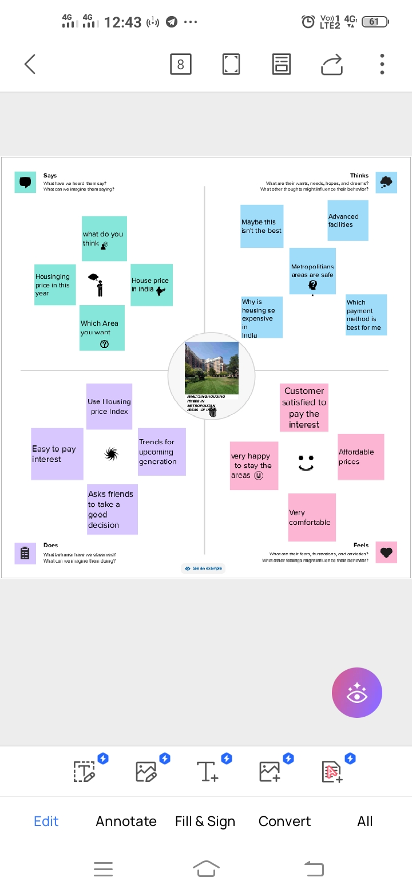

**BRAINSTROMING MAP**

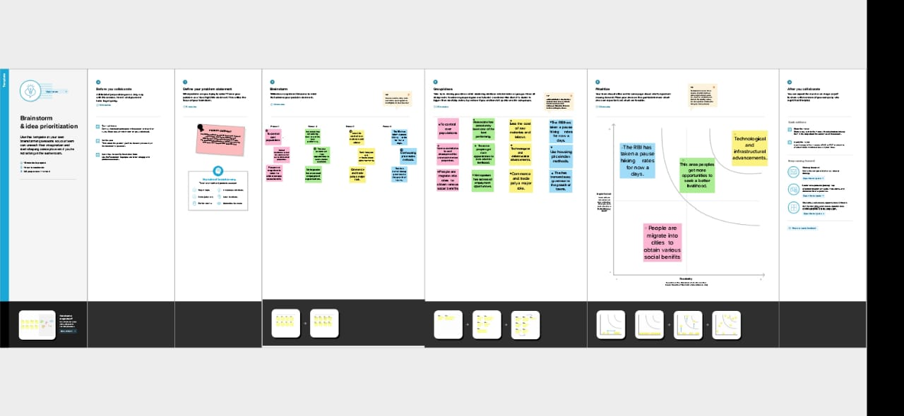

RESULT:

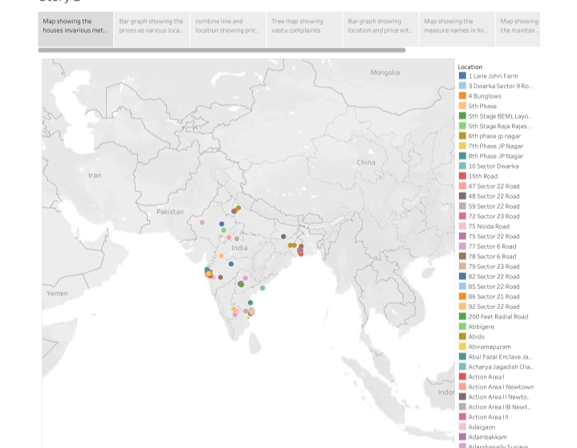

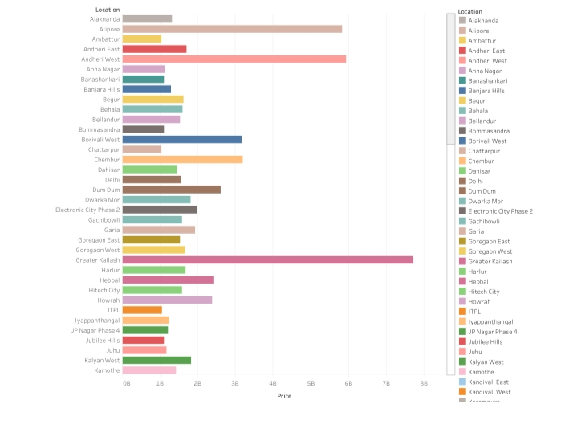

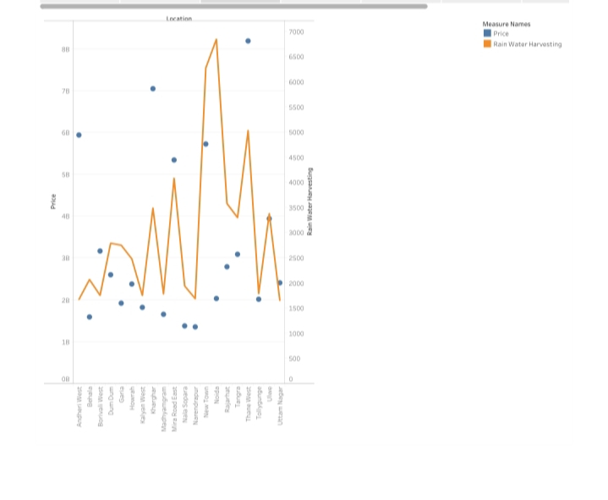

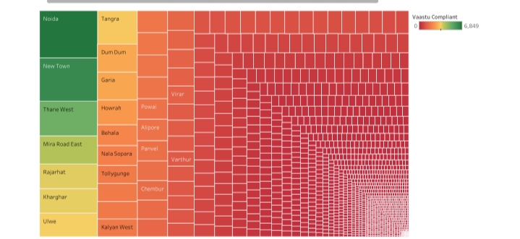

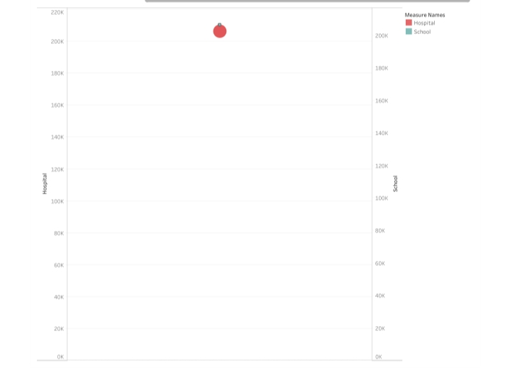

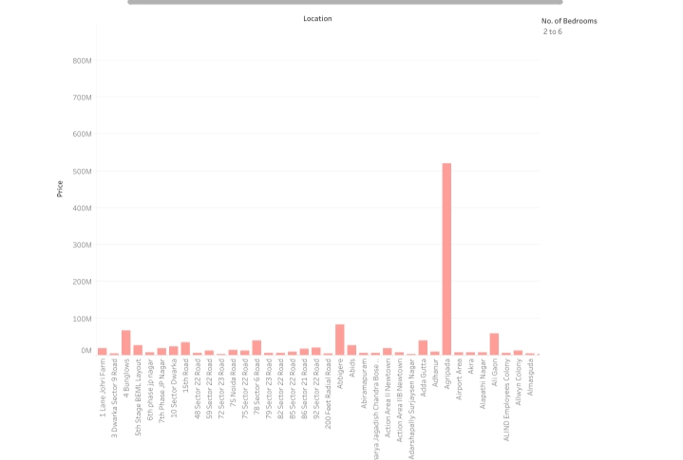

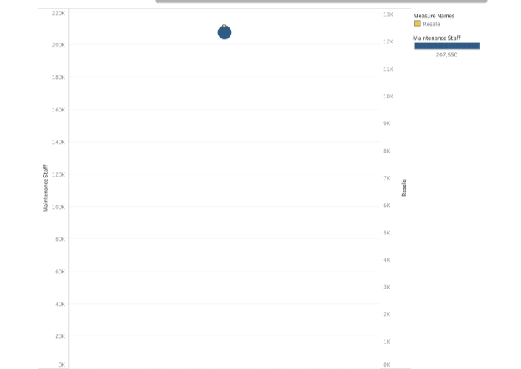

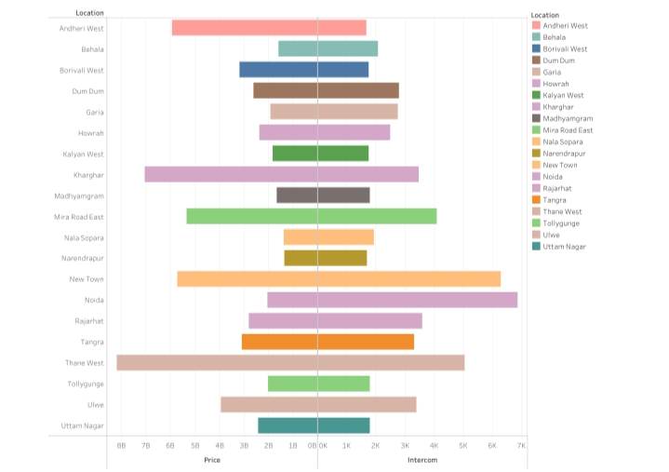

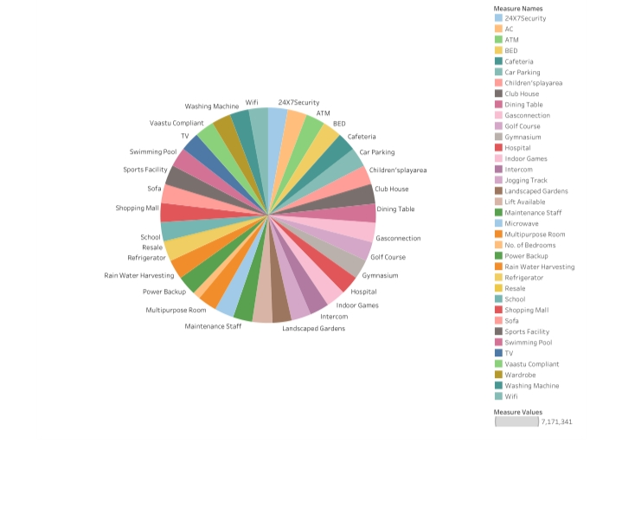

**ADVANTAGES :**

Gives structure to the strategy

2.improves perfomence reporting

3.makes is easier to communicate the strategy

**DISADVANTAGES:**

1.Apremium attached to the much in demand but limited in supply ready-to-move=in property

2.all these factors have collectively pushed up property prices across cities

**APPLICATION:**

1.Bangaluru too witnessed a 10 percent increase in prices to RS.8,688 per square feet

2.Chennai went up 6 percent to RS. 7,653per square feet

3.Housing prices in Hyderabad rose 13 percent to RS.10,530

**CONCLUTION:**

Based on the criterion of price convergence house prices in the 15 metropolitan cities do not converge to the LOOP .this implies that the housing markets in the different areas operate as segmented independent local markets

**FUTURE SCOPE:**

According to resent data from the national housing bank (NHB) housing prices have seen a steady increasesin various cities in india.

In the first quarter of 2022-23 housing prices rose in 42 cities while rates of residential units fell in five cities and remained stable in three cities